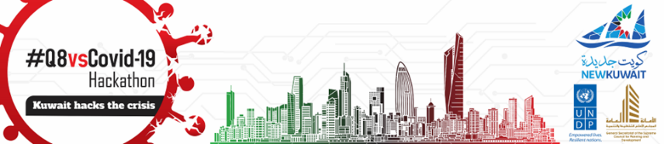

UNDP Support to COVID19 Response in Kuwait

In March 2020, the State of Kuwait made an early decisive move to enter e a national lockdown. Whilst the gradual economic reopening of four phases has been in place, and curfew was lifted at the end of August 2020, Kuwait ranks at 8th in the world for per million population infection rate. Further, as of September, the cases are still on the rise in Hawalli and Kuwait capital areas, indicating therefore the importance of sensitization of general public.

Our COVID19 support has a two-pronged approach. Firstly, critical and urgent policy research and analysis on COVID19 have been carried out with the framework of Kuwait Public Policy Centre project by repurposing project funding as directed by the Government. Secondly, in April 2020, UNDP Kuwait has received $250,000 from Rapid Response Facility (so-called RRF) funding managed by the UNDP Headquarters, because of criticality of COVID19 and envisaged impact on socioeconomic lives in the country. All the activities funding by the RRF have been planned and carried out in full consultation with the General Secretariat, the Supreme Council for Planning and Development (GSSCPD) to ensure national ownership and effective/relevant utilization of the RRF funding.

ADD LOGOS FOR KPPC, UNDP AND GSSCDP

- Support Provided By The KPPC Project

1. Policy Analysis and Research: Kuwait Public Policy Centre Project

In partnership with the GSSCPD, the central planning and coordination entity of the Kuwaiti Government, and the Kuwait Public Policy Centre (KPPC) worked with the Oxford Economics (OE), on macro-modelling to visualise potential scenarios that might impact Kuwait’s economic forecast given the COVID19 pandemic and declining oil prices and demand-trajectory of oil market. The modelling presented three scenarios - V (best case), U and L-shaped (worst case) recoveries that would enable government policy to prepare for different trajectories that might occur throughout the COVID19 crisis. Scenarios and potential economic outlooks were presented to the government in the form of weekly reports and the publication of two policy papers, including a white policy paper with assistance from economists at the UNDP Regional Hub to guide policy decision-making to mitigate post-crisis stage economic damage.

Through KPPC project, UNDP Kuwait also assisted the GSSCPD to produce a detailed recovery operational plan through a local consultancy firm consisting of multidisciplinary groups of expertise across the world. The project used various methods of local and international subject matter expertise, producing a four-stage plan prioritising sectors and industries built upon criteria:
- Contribution to GDP
- Percentage of Kuwaiti employees
- Risk of potential COVID19 transmission

Each industry and sector had contextualised guidelines and protocols in place throughout each stage. Recommendations were presented to the Council of Ministers, which adopted around 70 to 80 percent of the recommendations from the GSSCPD/KPPC alongside guidance from the World Health Organisation (WHO), guiding the gradual reopening of the country starting from June 1st 2020.

The KPPC/UNDP Kuwait’s resident Public Health Policy Advisor, from public policy perspectives, has published a series of situational awareness assessment reports in regards to the gradual easing of curfew policy, which included the following: :

- Assessment of comprehensive curfew policy. UNDP-KPPC, Policy Brief 20-9. (May 2020).
- COVID-19 Interim evaluation of Kuwait’s response to COVID 19. UNDP-KPPC, Policy Brief 20-8. (May 2020).
- COVID-19 Trend of 10 weeks epidemic. UNDP-KPPC, Policy Brief 20-7. (May 2020).
- COVID-19 Lessons learned from model countries of the COVID 19. UNDP-KPPC, Policy Brief 20-6. (April 2020).
- COVID-19 Issues and challenges of Gulf Countries brought by COVID-19 UNDP-KPPC, Policy Brief 20-5. (April 2020).
- COVID-19 COVID 19 and recovery issues. UNDP-KPPC, Policy Brief 20-4. (April 2020).

- Support Provided Through RRF

1. Training Of NGOs For Financial Reporting, Monitoring, Project Management And Accountability 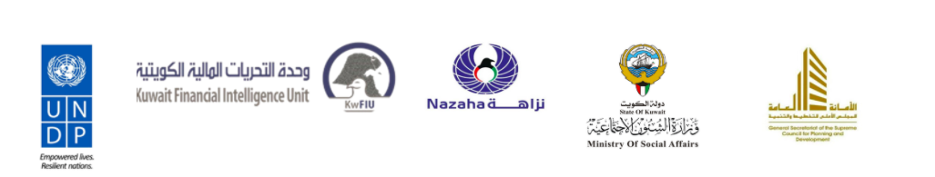

In the context of COVID19, vulnerable communities both Kuwaitis and foreign residents in Kuwait are negatively affected socially, economically and medically. As a response, 47 active Kuwaiti NGOs are on the frontlines, providing humanitarian assistance to individuals and families in need. Like in many other countries, the COVID19 brought a situation where rapid inflow of private and public donations to NGOs, who may not have sufficient experiences in financial management, project management and reporting while needing to deliver their support in a timely manner. Kuwaiti NGOs have been playing very important roles, as being closest to people and communities on the ground, even at a time of curfew in place. The importance and relevance of these local NGOs were highlighted by the Ministry of Social Affairs and NAZAHA (National Anti-Corruption Agency) and they highlighted capacity development support for the project and financial management in order to effectively manage their activities while being sensitized on the issue of financial transparency.

As part of an integral part of the implementation of the National Anti-Corruption Strategy, which was proclaimed by the Amir, His Highness Sabah Al-Ahmad Al-Jaber Al-Sabah, UNDP Kuwait and NAZAHA organised two virtual workshops on financial planning and project management from 10th June to 11th June 2020. The objective of the training is to instil project management and financial management methodologies as well as sensitizing the importance of accountability and preventing money laundering through transparency in their respective operations. The joint sessions were delivered by UNDP, Nazaha, the Ministry of Social Affairs and GSSCPD.

^{[1]} https://undp.sharepoint.com/teams/coronavirus/Shared%20Documents/english-covid-19-disability-briefing.pdf#search=disabilities%20covid
^{[2]} http://www.pada.gov.kw/MainLaw.aspx

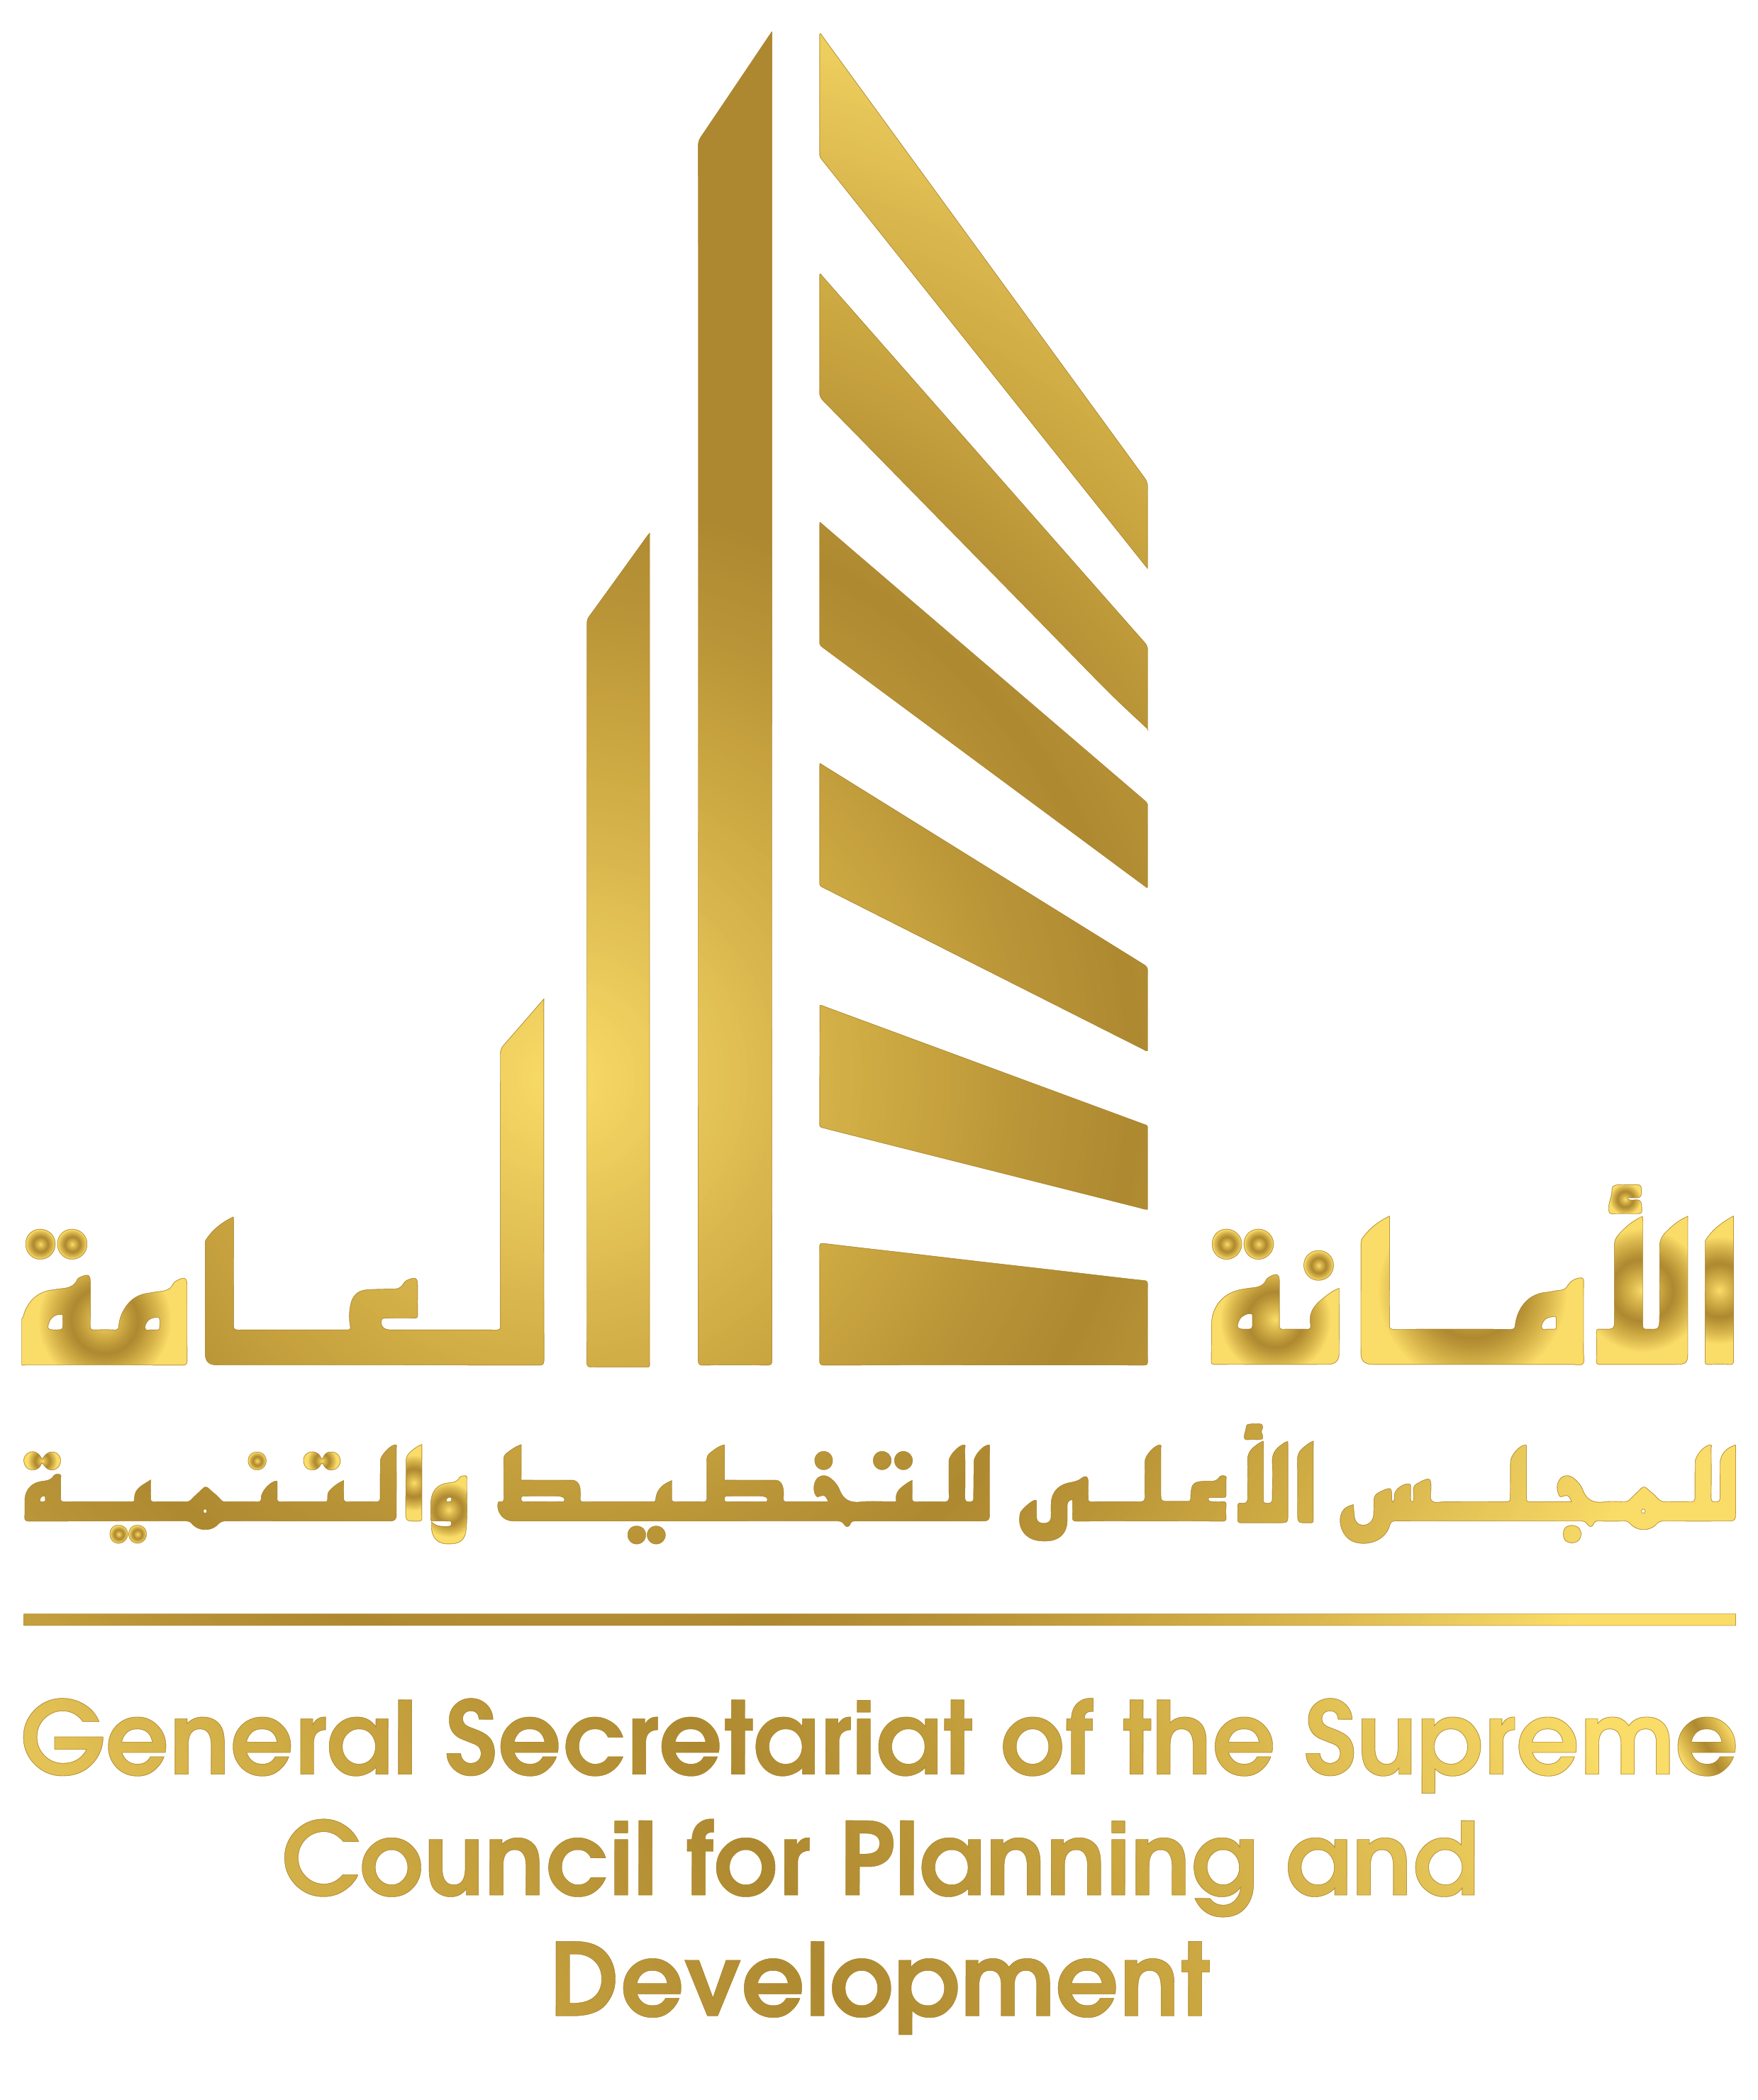
2. Training Of Trainers For Volunteers And Volunteer Management
Under the leadership of His Highness, the Amir Sheikh Sabah Al Ahmad Al Jaber Al Sabah, close to 4,000 of Kuwaiti volunteers are mobilized and engaged in the work at the field level, working closely with NGOs to support vulnerable communities and low-income, underemployed migrant workers. However, the response to action is hindered by lack of information on volunteerism as a profession. As a result, certain issues have arisen in the volunteer community, such as:
- Lack of awareness on abiding by a code of conduct;
- Friction between volunteers and certain local communities;
- Mismatch of volunteers’ skillset to the functions they have been assigned;
- Lack of understanding of volunteerism.

At the request of the GSSCPD, UNDP Kuwait, UN Volunteers (UNV) and the Ministry of Social Affairs have launched a series of capacity development training firstly to
- NGOs who are hosting local volunteers and key government officials on volunteer management and administration on 9 June 2020;
- Training of trainers (ToT), targeting lead volunteers on code of conduct, volunteerism and technical knowledge sharing. This initiative aims to have certified, trained Kuwaiti volunteers that could assist different government agencies and community service providers in the field during the crisis.

Against this background, UNDP and partner agencies have been working closely to deliver three deliverables. The first is the training of volunteer trainers (ToT) by conducting a half-day workshop held virtually on June 9th 2020. The training was geared mainly to members of Civil Society Organizations (CSOs) and the Ministerial Committee on volunteerism work. The informative training also invited resource persons from UNV, aiming at beefing up the capabilities of CSOs in managing volunteering work and learn the principles, code of conduct and guidelines to successfully administer volunteering work. The aim of the workshop was to equip the participants to become the trainer of the trainers. The trainers will be selected depending on their background, with GSSCPD, MOSA and UNDP aiming to have representatives from difference CSOs with targeted specialization in their fields (e.g. education, public health, economic, community service, among others). This approach will create a pool of volunteers that accommodate various sectors that require volunteering while spontaneously improving the quality and expected results of volunteers by allocating volunteers to their specific field of expertise. The training of volunteer trainers was facilitated by Mr Fuad Bousherhi, a pioneer in local volunteering in the State of Kuwait, together with UNDP and UNV.

The second deliverable centres around the training and quality assurance of volunteers, volunteers will be expected to be a part of the CSOs and they are expected to have the general notion and sentiments of a “sustainable volunteer”. The trainers that were trained in stage 1 will conduct these seminars and the trainees will be distributed based on their background and expertise. The trainees will be awarded a joint UNDP, GSSCPD, and MOSA certificate alongside a volunteer badge. This will create a huge intangible incentive for them to participate in the programme.

- SME Hackathon : #Q8vsCOVID19 HACKATHON SERIES

In partnership with the General Secretariat of the Supreme Council for Planning and Development (GSSCPD), the National SME Fund, Kuwait Foundation for Advancement of Science (KFAS) and UNDP Kuwait launched its first “Kuwait hacks the Crisis” Hackathon, as part of our #Q8vsCOVID19 series on April 2020.

The hackathon posed two challenges that the country is faced with COVID19, there are:
- Overcoming supply-chain vulnerabilities
This hackathon challenges SME participants to come up with an innovative solution to overcome potential supply-chain constraints, slowdowns, or even breakdowns for commercial commodities and services affected by COVID19 and similar crises in the future in the following sectors: Food, non-food commodities, and services.
- New innovative business ideas for health services and wellbeing:
The hackathon is seeking innovative business ideas in the health service sector at the time of COVID19 crisis and beyond in the longer-term.

Participation was aimed at local SMEs with innovative solutions to tackle socioeconomic challenges incurred by COVID19 pandemic. Selection criteria was narrowed to Kuwait-based SMEs. Each team would have at least 3 to maximum 7 members, with at least one member being a Kuwaiti citizen. SMEs formed with a multidisciplinary team that benefit from diverse background, ideas and experiences were encouraged to apply to participate. Registration was open to the public on May 4th 2020 t May 11th 2020 with onboarding of the participants and opening ceremony on May 13th 2020 officially beginning the Hackathon challenge. The Opening ceremony included remarks from the organisers and partners, including:
- Director-General of KFASD. Adnan Shihab-Eldin;
- Director General of The National Fund for SME Development, Manaf Al-Menaifi;
- Secretary General of the Supreme Council for Planning and Development, Dr. Khaled Mahdi;
- UNDP Kuwait Resident Representative, Hideko Hadzialic;
- Director General Kuwait Institute for Scientific Research, Dr. Samira Omar;
- UNDP Innovation Advisor, Jennifer Colville who acted as moderator

Participants were supported by coaches made up of a multidisciplinary team of advisors and experts from various backgrounds, ranging from innovation advisors, business administration, science and public administration. The role of the coaching team was to facilitate teams’ design thinking and encourage discussions amongst team members to arrive at a set of innovative solutions. Teams were given 5 days to develop a solution. Judges, made up of a multidisciplinary team, consisting of advisors from different institutions evaluated the proposals:
- Judges evaluating Challenge 1 consisted of representatives of KFAS, FAO (Food and Agricultural Organization), GSSCPD and UNDP.
- Judges evaluating Challenge 2 consisted of representatives of KFAS, KISR, SME Fund, GSSCPD and UNDP.
Each challenge was given a set criteria designed for the problem at hand to guide judges in evaluating teams’ solutions. Central to evaluation was the degree to which a solution can contribute to SDG goals and/or to any of the 7 pillars of Kuwait Vision 2035. Two winners were chosen and awarded 5000 KWD.

The winners were:
- Challenge 1: Tasted & Tested - Kuwait Dairy and Food Establishment
  - Idea Statement: "Thiqa" is a virtual market to reduce unnecessary wasted vegetables and fruits by connecting farmers and consumers while ensuring quality assurance.
- Challenge 2: MAZ - Blocktech Technology
  - Idea Statement: IBN-SINA Integrated Digital healthcare Records system that interconnects three stakeholders of the healthcare eco-system: patients, healthcare providers, and health ministry authorities.

- Regional Ideathon
The second event held as part of our #Q8vsCOVID19 Hackathon series was the Regional Ideathon. The purpose of developing a mass-scale event was to bring about and create a knowledge-based community of likeminded individuals who have the capacity and capabilities to develop solutions towards adapting an efficient and effective public sector institutional framework that can maintain/increase labour productivity under the ‘new normal’ brought about by the COVID19 outbreak .

In the context of the public sector, this includes developing/adapting to new ways to ensure continuity of work and administrative functions, maintain service delivery, optimize engagement and collaboration, share knowledge and learning, break down organizational silos that may be reinforced by this new arrangement, etc. ​ This Regional Ideathon challenged teams to identify specific challenges facing public sector entities and propose innovative ideas for solutions that can make adaptation to the new normal effective and efficient. Teams were encouraged to think of solutions that can eventually be translated into regular work settings as well.

Only citizens and residents of Arab States were allowed to participate. Each team would have a minimum of 3 to maximum 7 members, with at least one member being a Arab State citizen and one member working in the public sector. Registration was open to the public for 7 days starting from September 6th to September 12th 2020, which was then followed by the opening ceremony held on September 13th 2020, which included remarks from:
- Secretary General of the Supreme Council for Planning and Development, Dr. Khaled Mahdi;
- UNDP Kuwait Resident Representative, Hideko Hadzialic;
- Resident Representative World Bank Country Office Kuwait, Ghassan Alkhoja.
- Advisor to Secretary General of the Supreme Council for Planning and Development, Dr Faleh Alrashidi who acted as moderator

Similar to the first Hackathon challenge, coaches of similar calibre and expertise provided teams with support to facilitate teams’ design thinking and encourage discussions amongst team members to arrive at a set of innovative solutions. Teams were given 4 days of orientation, including a series of webinars that describe the challenges public institutions face during the pandemic with a focus on:
- Crises Management;
- Processes and Procedures;
- Team Management and Employee Productivity;

After orientation, teams were assigned a coach and given 4 days to develop their solutions and given a deadline on September 21, 2020 at midnight to submit their idea. Overall, 77 submissions were collected from 17 countries. Similar to the first series, Judges were made up of a multidisciplinary team, consisting of advisors/experts from different institutions and organisations focusing on public administration evaluated the proposals. Evaluation was based on a detailed selection criteria including, but not limited to, the extent the solution can be implemented in the COVID19 context, beyond the COVID19 context and how it may contribute to UNDP’s SDG goals.

The award ceremony was held on December 8th, 2020 where 3 teams were announced winners of cash prizes consisting of:
- 1st winning team (USD 15,000) from Bahrain “The Government Talent Cloud Project” - a mechanism that allows the government employees to register their talents, knowledge and skills in the cloud, to capture and mobilize talents within the Civil Service Bureau, whereas employees could be rotated within their organizations and/or between the different government entities according to their talents and to which they will be able to continue adding value.;
- 2nd winning team (USD 10,000) from Yemen “Educore” - solve remote education problems using local servers that carry a system and database that collects educational materials of all educational facilities, and distributes them to telecommunications exchanges and internet service providers, ensuring accessibility to the system from all residential areas, using the Metropolitan Area Network (MAN), without the need to access the Internet.;
- 3rd winning team (USD 7,000) from Lebanon “Intersect: Government as A Service”- Online Digital Platform. Online digital platform that provides a matching system which not only develops technical skills but also builds skills through experience and training.

Support to the winning teams will be given post-ideathon provided by the UNDP to assist them in implementing their idea through learning opportunities

- Behavioural Insights (INCLUDE KPPC LOGO)
The social impact COVID-19 has brought on is both complex and multifaceted, affecting individuals’ perceptions and actions. Faced with adversity, individuals’ responses and reactions influence their behaviour, which in turn can prove to be polarised under the false sense of unity ^{[1]}.

In partnership with Kuwait Public Policy Center (KPPC), UNDP Kuwait carried out ongoing behavioural analysis under UNDP Kuwait’s Rapid Response Facility. Led by UNDP Kuwait’s Fatima Keik (KPPC Project Coordinator) and Dr Sungsoo Chun, research conducted aims to gain clear insight into the behavioural responses towards COVID-19 through the dissemination of a survey questionnaire. With the agreement of the GSSCPD, UNDP Kuwait decided to focus on the effect of COVID19 lockdown on mental health and physical wellbeing. Before designing a behavioural intervention to reduce the negative effect of the crisis on physical and mental health, an online questionnaire was prepared in collaboration with the Public Health Advisors at the KPPC.

The purpose of the study was to measure behavioural changes impacting mental health, food consumption and wellbeing brought about by the outbreak of COVID19 in comparison to behaviours before the outbreak. The survey aimed to assist in the production of a behavioural insights report that would assist in developing intervention strategies (TBD) and a possible chatbot rollout in relation to wellbeing and mental health (TBD)

The questionnaire was designed to be gender sensitive and disseminated using a tailored communication campaign in multi-languages (Arabic, English, Hindi, Urdu and others). The questionnaire covers the following areas:
● Demographics and background information Perception, Attitude, and Practice about COVID 19;
● Mental health assessment (depression, stress, and anxiety);
● Food consumption;
● Exercise and physical activity;
● Relationship Dynamics (domestic violence and abuse).

The survey was rolled out from June 18 to July 15, 2020, through social media, including WhatsApp and Facebook. The target population was the Kuwait residents over 21-year-old who is living in the territory of the State of Kuwait. Finally, 679 cases (57.9% of females and 42.1% of males; 67.7% of Kuwaiti nationals and 32.3% of non-Kuwaiti nationals) were analyzed.

A policy report was developed analyzing the results and findings. The results show that there are weaknesses of coping COVID-19 and mental health, being urgent needed to intervene for health behaviors and social supports, including coping methods for COVID-19 stress, systems for family counsel, community supporting environment for encouraging a healthy lifestyle (Final Report TBD).

6.Development of Chatbot powered by Artificial Intelligence (AI) to improve the wellbeing of people during the crisis.
Results from mental and physical health questionnaires will assist in the design of an interactive platform. The interactive WhatsApp platform is aimed at Kuwaiti citizens and residents towards accessing information related to their health on a real-time basis.

The objective of the chatbot is to communicate to residents and disseminate information related to their health through:
● Symptom assessment related to COVID-19;
● Daily health tips;
● Mental health counselling;
● Access to appropriate services.

This project is ongoing (End date TBD).

7.Development of a policy paper, titled: “Polarized Reactions, Attitudes and Behaviors towards Covid-19: Behavioral Analysis”.
The paper was produced by UNDP Kuwait’s Fatima Keik and published in September 2020, focusing on the cause of polarised reactions towards COVID-19, suggesting a “Behavioral Reaction Spectrum” that explains how people are polarized in the way they react to the pandemic.

Aim: “The main objective of behavioural interventions by governments should be to instil collective action and community engagement and cooperation; where the safety and wellbeing of others are as important as the wellbeing of an individual. And if such change is hard to maintain and sustain, then governments should be cautious in the communication tools and strategies to strike a balance between fear and optimism. This is where the role of behavioural insights stems and is of critical importance. It includes both the knowledge of what drives behaviours as well as tools on how to encourage the right behavioural change^{[2]}.”

The report hypothesised that the root cause of opposite reactions caused by different interpretations of information and individual’s perceptions due to inherent biases and heuristics. Through behavioural analysis, it was explained that underlying behavioural biases influence how and why people are behaving the way they are. Opposite polarised reactions were driven by individualistic reaction in responding to the pandemic. The nature and risks of the virus require a collectivist attitude rather than an individualistic one. As a result, the paper recommended that government regulations must consider the culture, context and characteristics of different communities. Policies should be based on scientific research, as well as behavioural insights. Government should strike a balance between fear and optimism to bring together the “underreactors” and “overreactors” towards collective action.

^{[1]} Polarized Reactions Towards COVID-19: A Behavioral Analysis, Fatima Keik, September 2020
^{[2]} Polarized Reactions Towards COVID-19: A Behavioral Analysis, Fatima Keik, September 2020

8.SDG-5 Gender-Sensitivty Media Training: "Towards a More Sensitive and Responsive Media to Gender Issues"
On 25th September 2005, HH Sheikh Sabah Al Ahmad Al Jaber Al Sabah, Amir of the State of Kuwait, pledged Kuwait’s commitment towards the implementation Agenda 2030 and the 17 Sustainable Development Goals before assembled world leaders at the United Nations Sustainable Development Summit in New York. The Kuwait National Development Plan (KNDP) 2015-2020 has also established a set of goals to assist Kuwait in eliminating all forms of discrimination against women.

UNDP Kuwait, in partnership with Kuwait University’s Women’s Research and Study Center, has produced initiatives aligning with SDG 5 and KNDP’s strategic objectives through a broad-based, inclusive approach with the contribution of various internal and external stakeholders from the UN, government, civil society, academia and media.

A negative outcome of the emergence of COVID-19 is the increase in violence against women and girls (VAGW), with the expansion of a national lockdown as a means to contain the spread of the virus, women and girls increasingly find themselves isolated from the people and resources that can help them^{[1]}. [AA1] With a great concern that the pandemic might impact and/or push back fragile progress on gender equality, Kuwaiti authorities, civil society, academia and the private sector are actively supporting key issues in relation to legal reform, economic empowerment and further research and data collection[AA2] .

Current media reporting on COVID-19 details how mortality rates from COVID-19 is higher for men. However, media fails to address different factors that disproportionately affect women^{[2]}. Women are more likely to take on childcare duties, made redundant, and have non-COVID related healthcare needs ignored, due to the pandemic.

UNDP Kuwait and UN Women Regional Office for Arab States partnered together, along with national partners, to accelerate the implementation of SDG 5^{[3]}. The joint programme focuses on three elements:
1. Output 1: Gender content in media
a. Why it’s important to encompass gender in media reporting?
b. Inherent biases
c. The role of culture in normalising gender stereotypes

2. Output 2: Media reporting of VAGW
a. Inclusive gender language
b. How is media reporting VAGW during COVD19?

3. Output 3: Organisational solutions to avoid bias in communication.]
a. Media organisations’ responsibilities towards gender-balanced coverage

From 27th – 29th of July 2020, UNDP Kuwait conducted a 3-day virtual workshop (3-hours each) with journalists and medua professionals from various local media outlets the title which came within phase 2 of the State of Kuwait Project to achieve SDG5. Media, as an outlet and sector, has an obligation to offer and produce professional coverage and reliable information to the public. UNDP Kuwait considers gender sensitivity as a priority in how the media portrays the pandemic.

Moderated by Dr Rula Alfarra Alhroob, with support from the Director of Kuwait University’s Women’s Research and Study Center, Dr Lubna Al Kazi, The workshop aimed at sensitizing journalists from TV, Radio, and Newspapers, as well as Media Personnel from the Ministry of Information towards gender issues when reporting or producing Media content and Materials through traditional Media outlets and online Media. It also aimed at improving the quality of their work from a gender perspective, by encouraging gender balance in their production of content and methods to avoid gender bias and discrimination in their coverage through gender stereotypes and images^{[4]}. In total, 16 participants (5 men, 11 women) attended the workshop.[AA5]

Contributing to the agenda was UN Women and UNDP, presenting concepts on how women are reported and alternative solutions to communicating women-related content. General terms were also addressed and discussed such as sex vs. gender, the unfair distribution of resources in society from a gender perspective, Gender equality vs equity, Gender parity vs gender balance, and women empowerment vs gender equality, as well as gender sensitive media vs gender biased media and gender neglect ant media, gender gap and Gender Gap Index, the status of Kuwaiti women on this index, and why we need equal rights for women, and the relation-ship between SDGs and women rights and responsibilities and opportunities^{[5]}.

Each workshop focused on different aspects of gender sensitivity, conducted through PowerPoint presentations, interactive quizzes and debates with a focus on language, discourse and images that influence media’s portrayal of women negatively.

The workshops proved to be successful in creating a safe environment for learning and training media personnel to reflect on micro- and macro- levels of gender portrayal and its direct impact to gender equality.

The aim of the workshop was first to enhance the knowledge and skills of media persons from different outlets to provide a diverse, balanced and gender sensitive coverage and reporting within the context of COVID-10. Second, to improve the quality of media work from a gender perspective, as well as help the different media outlets to strike a gender balance in their production of content and avoid gender bias and discrimination in their media coverage.

^{[1]} The Shadow Pandemic: Violence Against Women and Girls and COVID-19, UN Women, 2020
^{[2]} “The Media Is Covering Covid-19’s Disproportionate Impact On Women. But Not The Underlying Gender Inequality That Made It This Way Is Covid-19--And The Lockdown--Going To Affect Women, And Gender Equality In The Longterm?”, Jeremy Ullmann, 2020
^{[3]} Project Document: Support the State of Kuwait in the Implementation of SDG 5 on Gender Equality, 2017
^{[4]} Mission Report on The Consultancy Service provider for developing and facilitating a training workshop on “Gender Sensitive Media” within the frame of supporting Kuwait to achieve SDG 5- phase 2, Dr Rula Alfarra Alhroob, 2020
^{[5]} Mission Report on The Consultancy Service provider for developing and facilitating a training workshop on “Gender Sensitive Media” within the frame of supporting Kuwait to achieve SDG 5- phase 2, Dr Rula Alfarra Alhroob, 2020

9. Socio-Economic Analysis on the effect of COVID-19
UNDP Kuwait is leading a socioeconomic assessment on the impact of COVID19 on the most vulnerable groups such as people with disabilities (PWD) and migrants. Collaborating with the Public Authority of The Disabled (PADA), UNDP Kuwait aims to provide a review and analysis on current social protection processes put in place for PWD. The assessment will build upon a questionnaire designed by Dr Sungsoo Chun, focusing on areas relating to issues on daily life under COVID19, education, employment, leisure and culture, health, life satisfaction and social services needs. The questionnaire will be distributed amongst 50,000 Kuwaiti citizens registered under PADA and their careers. The assessment seeks to provide actions taken by the government, civil society and the private sector to as a means of addressing issues affecting PWD. Furthermore, the socioeconomic assessment seeks to shed lights on remaining challenges while providing new opportunities and initiatives as a means to advancing Kuwait National Development Plan policies.

The project is still in development with end date to be announced.
10. SDG Accelerator Pilot Project

UNDP Kuwait, in collaboration with UNDO Moldova and the General Secretariat for the Supreme Council for Planning and Development (GSSCPD), are developing business opportunity mapping as a result of COVID19 and post-COVID19 new normal in support of SMEs. The SDG Accelerator project is a well-established UNDP global initiative aiming to accelerate business solutions for the Sustainable Development Goals (SDGs). The accelerator programme offers SMEs an opportunity to align their business model to have a direct impact of the SDGs by developing innovative solutions. The SDG accelerator project will provide a new pathway in operationalising sustainable development in a business context.

The SDG Accelerator process will provide participating companies expertise guidance and a comprehensive method from ideation to development of new products, services and/or business models by focusing on fast-tracking ideas with strong SDG and business potential. The three main pillars of the programme are to enable SMEs to transform their innovation journey, enhance employee engagement and developing internal campaigns and activities.

The SDG Accelerator aims to:
- Develop a variety of SDG solutions through the promotions of sustainable innovation in the local SME ecosystem;
- Utilise innovation as a cornerstone for sustainable business development;
- Create an adaptable model that can be outsourced by SMEs outside of this initiative

The pilot project’s aim are:
- Support three local SMEs in developing sustainable business models/services/products;
- To contextualise the market opportunities and challenges (from a legal standpoint) faced by SMEs within the framework of the COVID19 pandemic and post-pandemic period;
- Provide a scale-up model (in collaboration with UNDP Moldova and UNDP Denmark), including the overall vision, methodology and proposal to assist the government on establishing strategic partnerships to support local SMEs.
  - The pilot phase is finance by UNDP Headquarters Rapid Response Facility.

The SDG Accelerator pilot will be supported by UNDP and a business consultant with expertise in design thinking and business modelling. The process focuses on the SME’s innovation journey by analysing the SME’s SDG problem and ends with integrating the solution into their business operations.

The programme’s told will be adjusted to the context of COVID19, the Kuwaiti market and the needs of local SMEs. The programme offers participating SMEs with:
- Inception workshops introducing UN Guiding principles on business and human rights, SDGs, CSR and showcasing real-life examples of SDG-aligned corporate strategies;
- Acceleration workshops to adapt business models to incorporate, expand their product and/or service portfolio to incorporate SDGs;
- Support in business modelling and pitch practice;
- Support in testing, prototyping, designing strategic roadmap and developing new operational frameworks;
- Offering guidance and consultation throughout the programme;
- Transforming their business models to incorporate UNGPs.

The SME Accelerator pilot project is still in development with end date TBA.

Concept Note: Volunteering Training and CSO Support, UNDP Kuwait, 2020
Concept Note: Volunteering Training and CSO Support, UNDP Kuwait, 2020
Ideathon Concept Note, UNDP Kuwait, 2020

